CWC Data Collection System Manual
December 5th 2021

Assembly
All subsystems of this system have two parts: power generation and parameter testing. When you need to test a subsystem, please first connect the following interface and laptop (or any digital device with Labview Vi) to the Data Box (figure 1) provided by this project. There are three subsystems:
1-wind power subsystem,
2-thermoelectric subsystem,
3-solar power subsystem,
4-Data Collection subsystem.

And two external equipments:
- Laptop,
- Programmable Electronic Load.

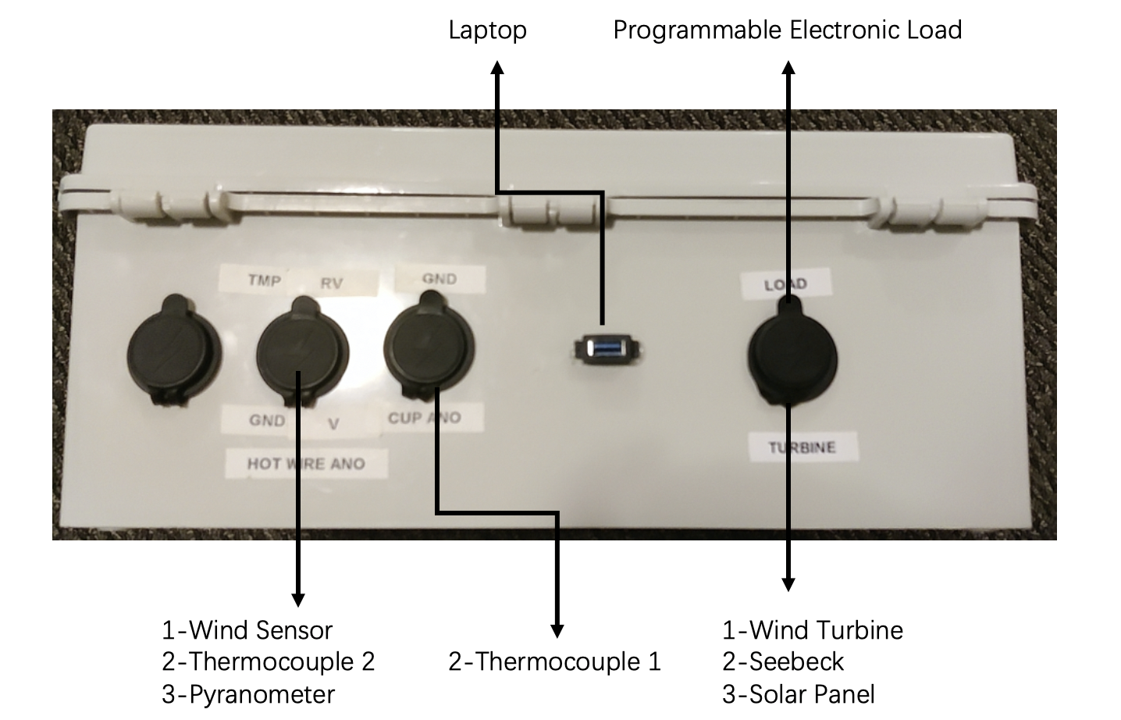
Figure 1. Total Interface

Wind power subsystem

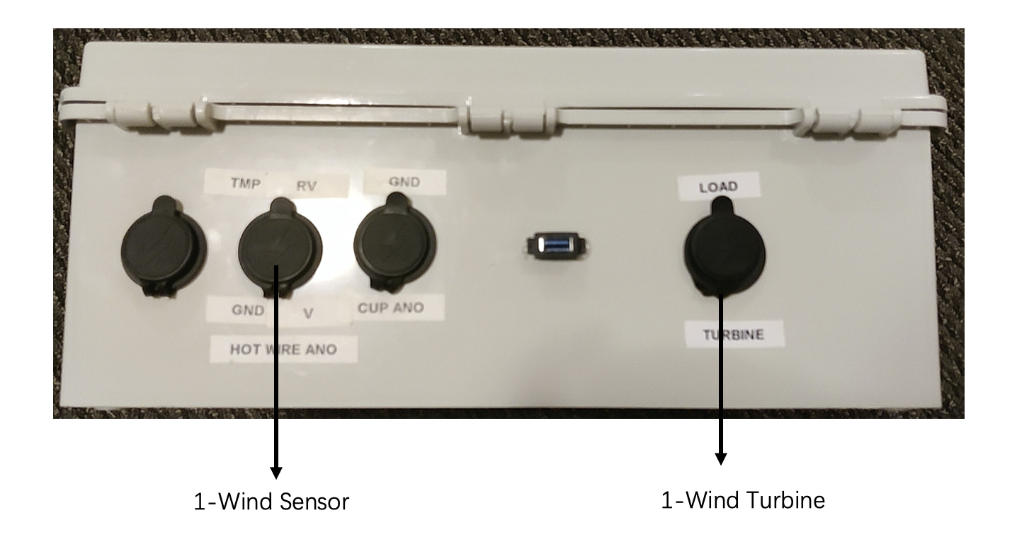
Figure 2. Interface of Wind Power Subsystem

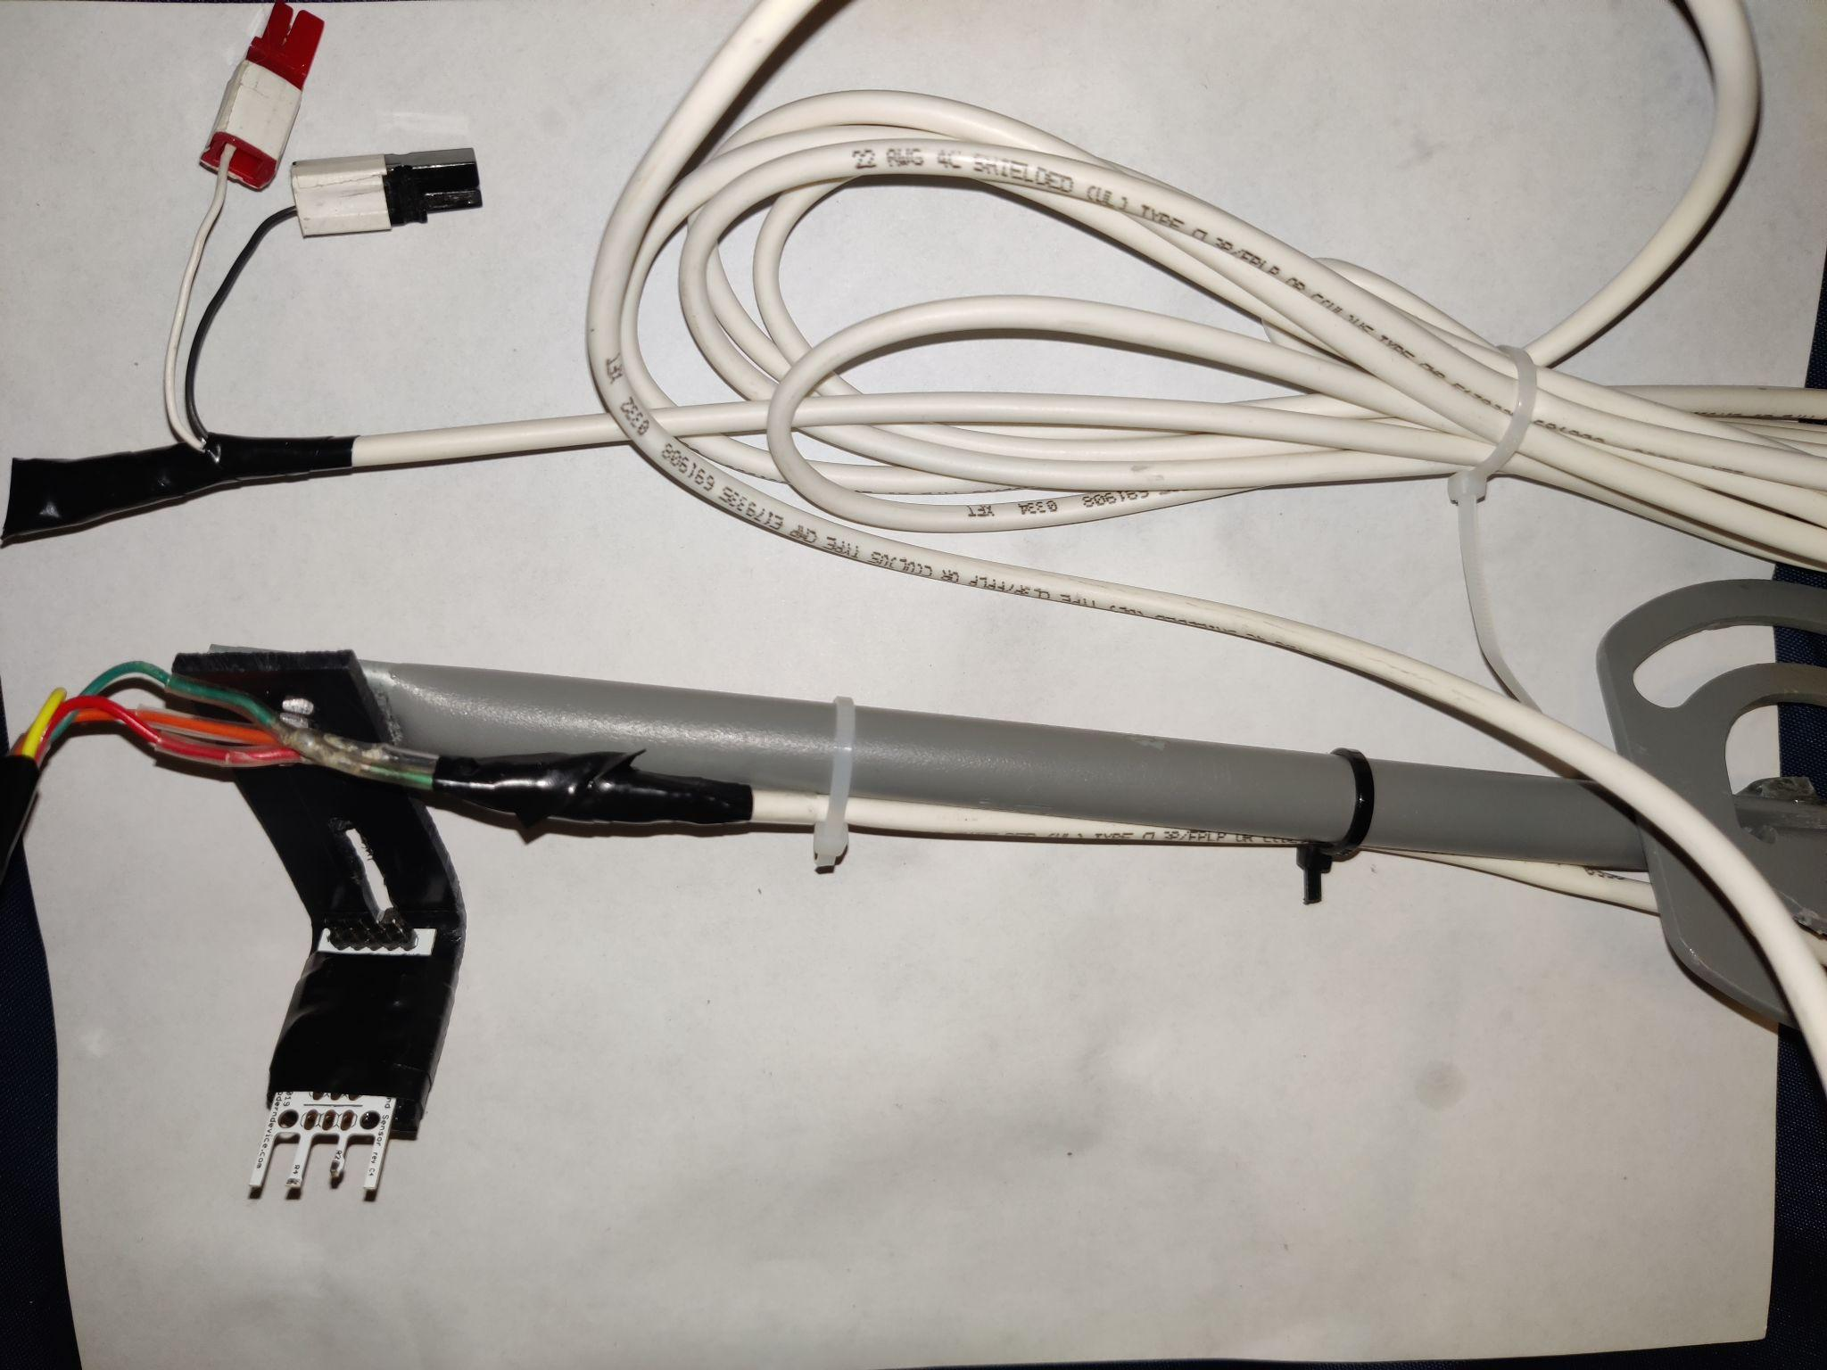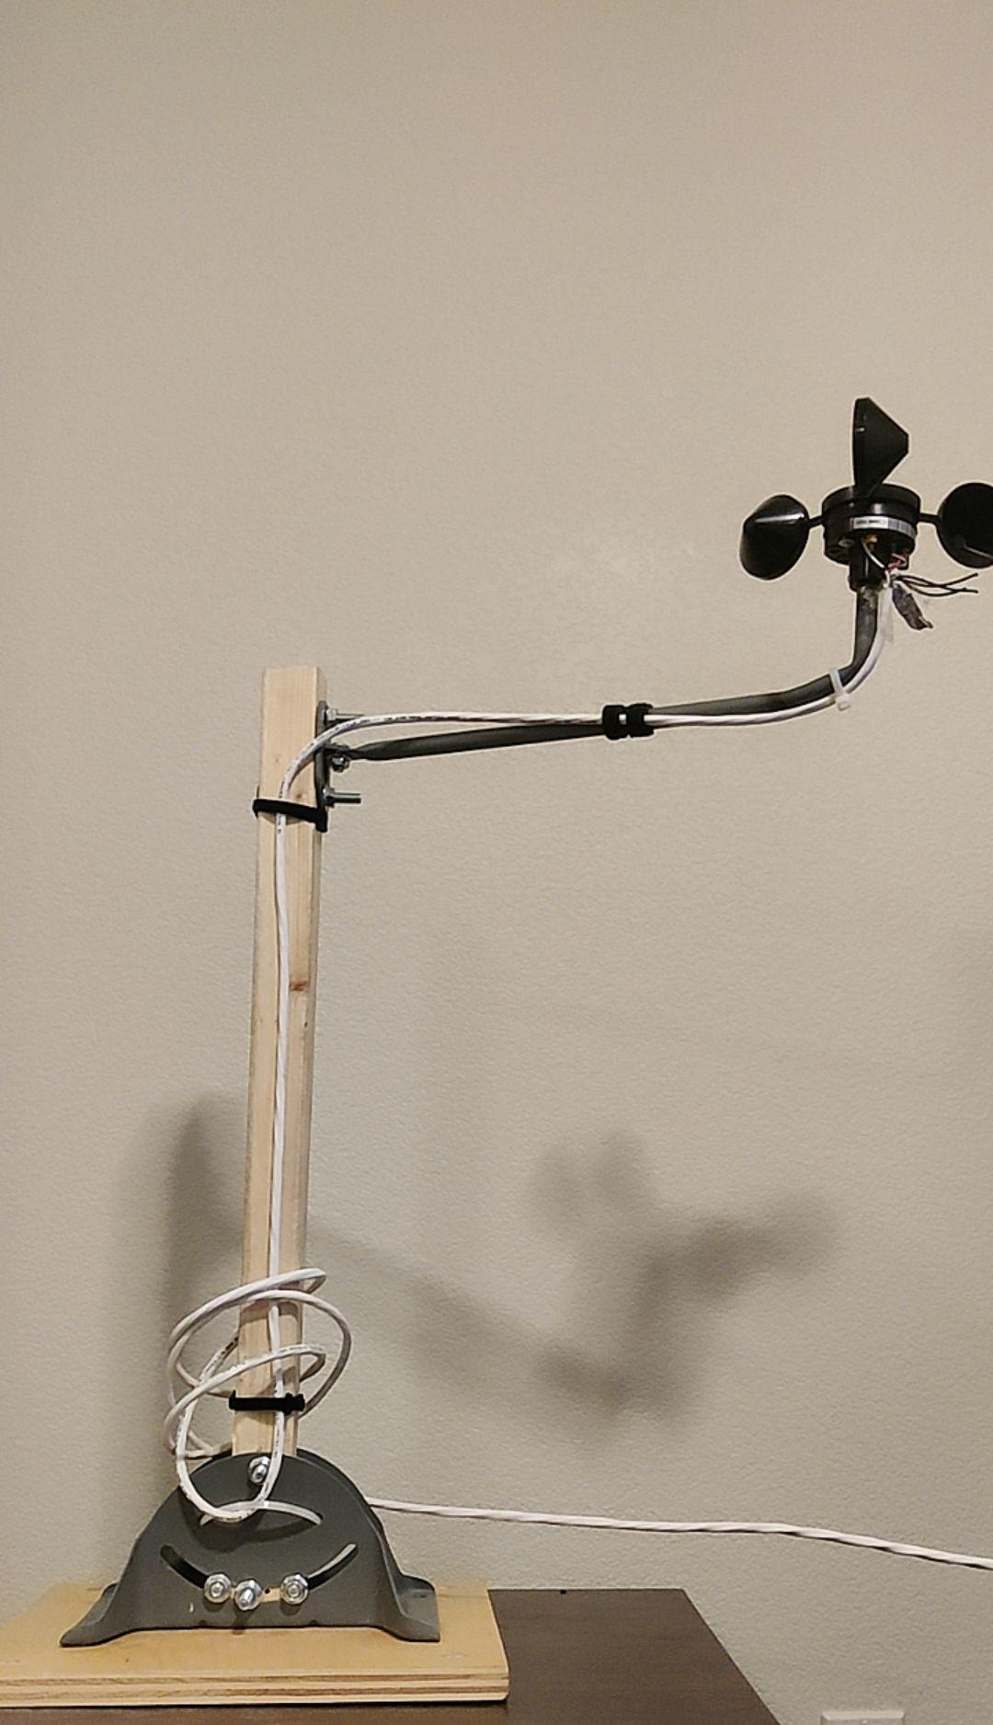
Figure 3. Wind sensor and Wind Turbine

Thermoelectric subsystem
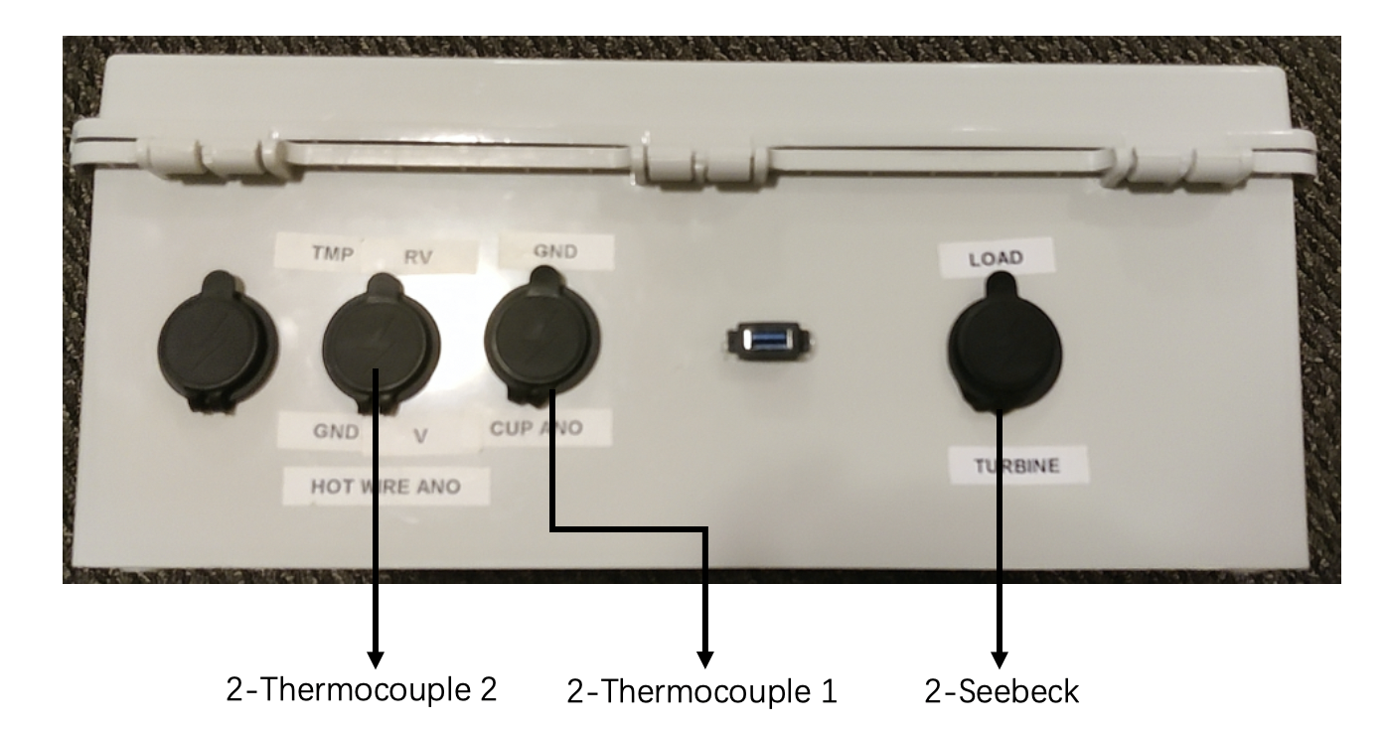
Figure 4. Interface of Thermoelectric Subsystem
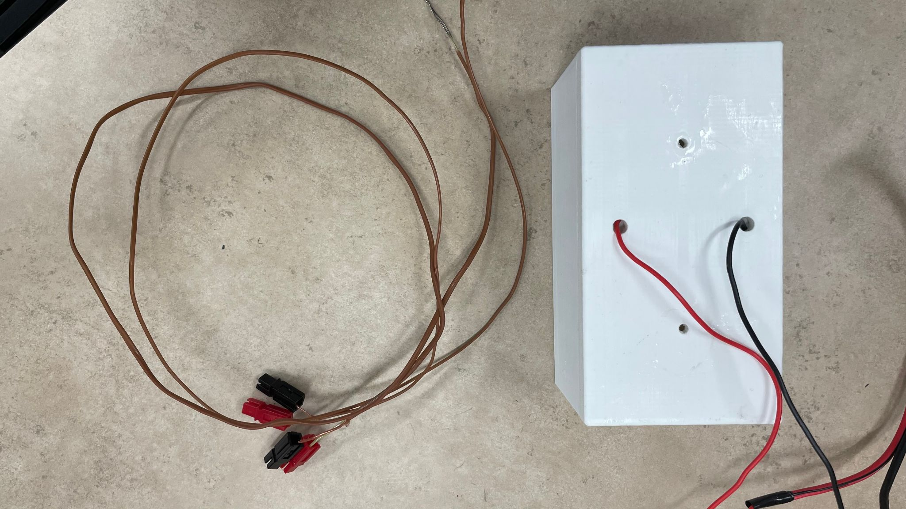
Figure 5. Thermocouple and Seebeck

Solar power subsystem
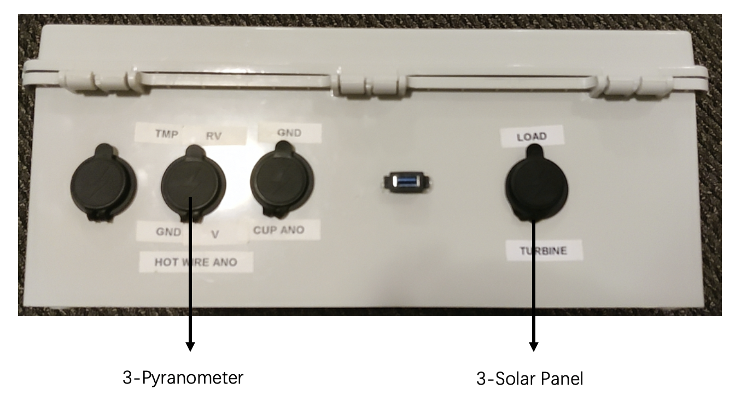
Figure 6. Interface of Solar Power Subsystem
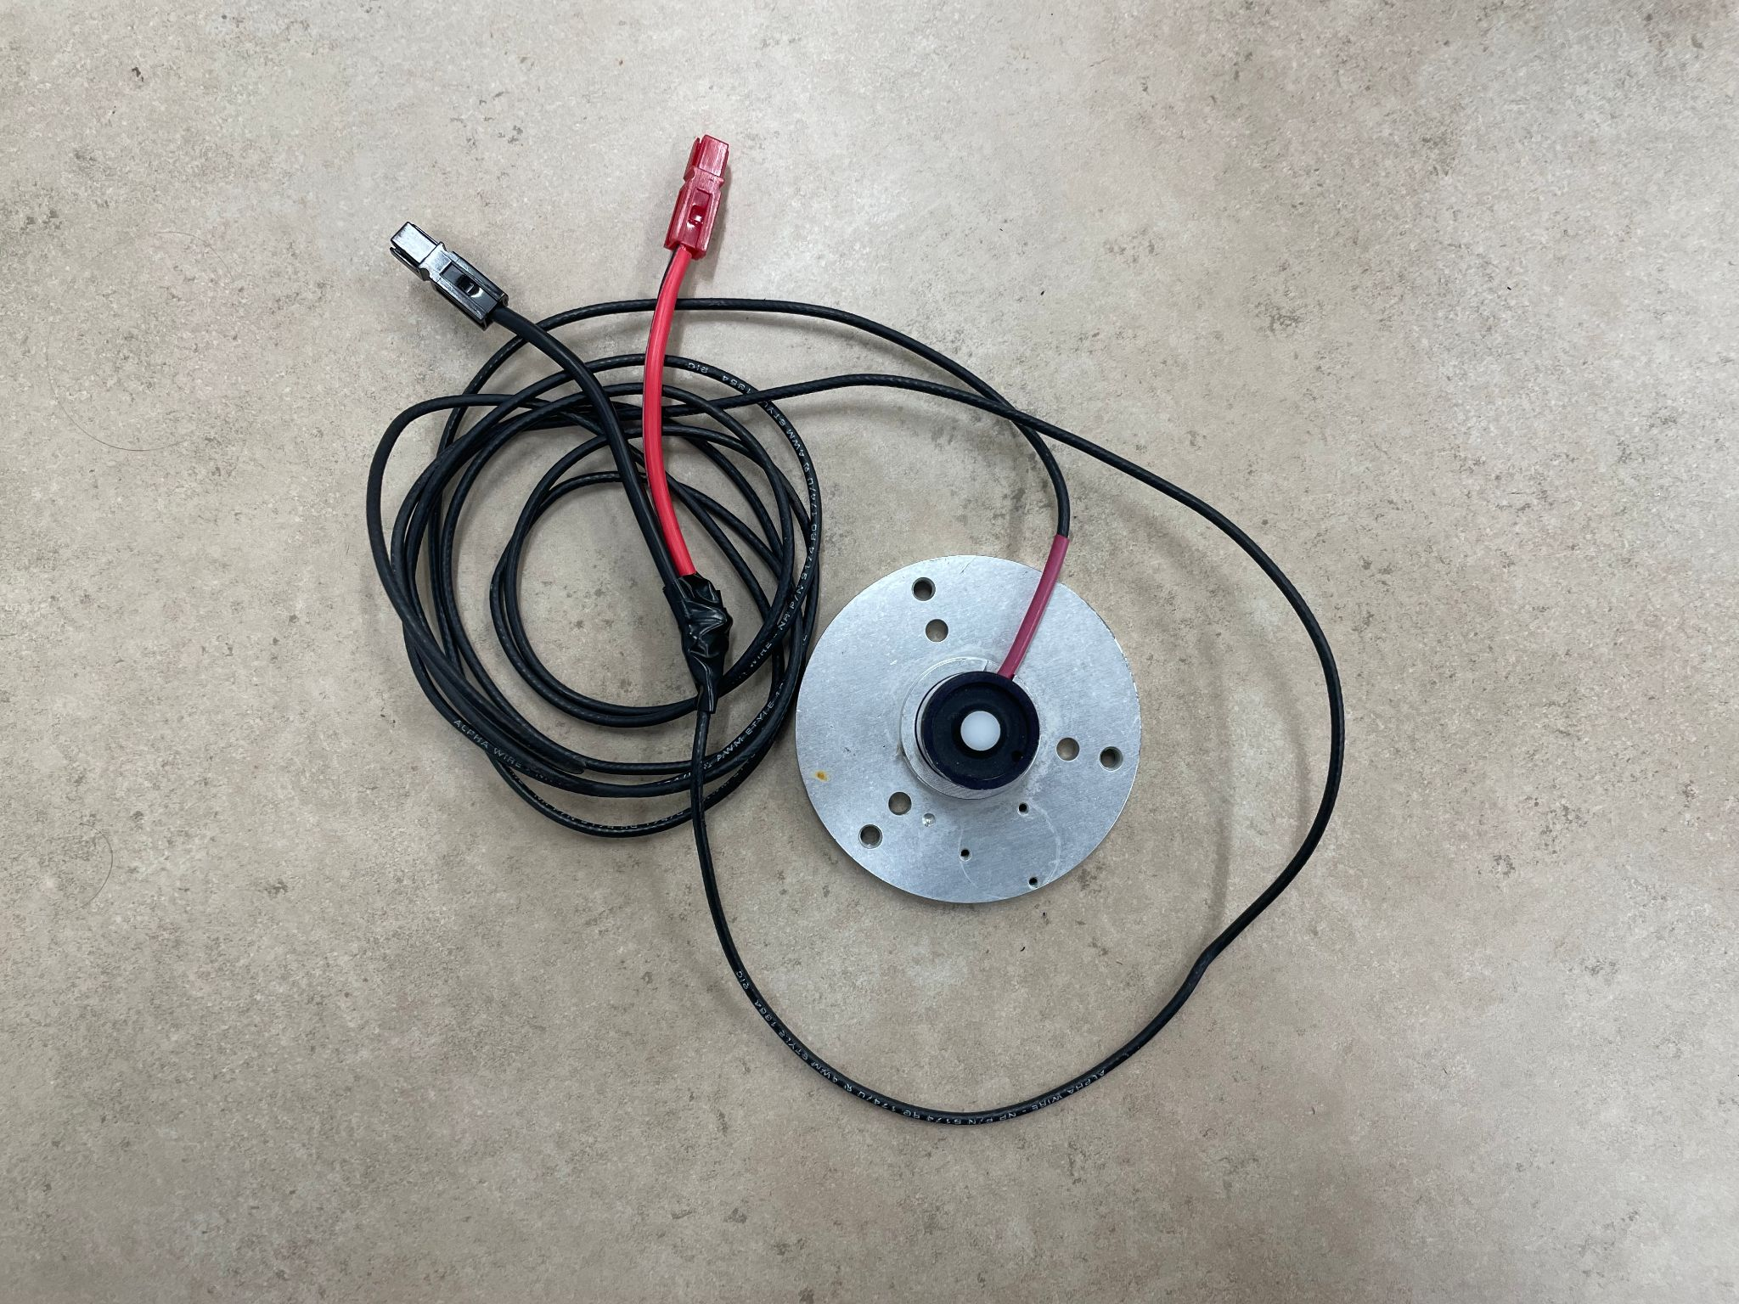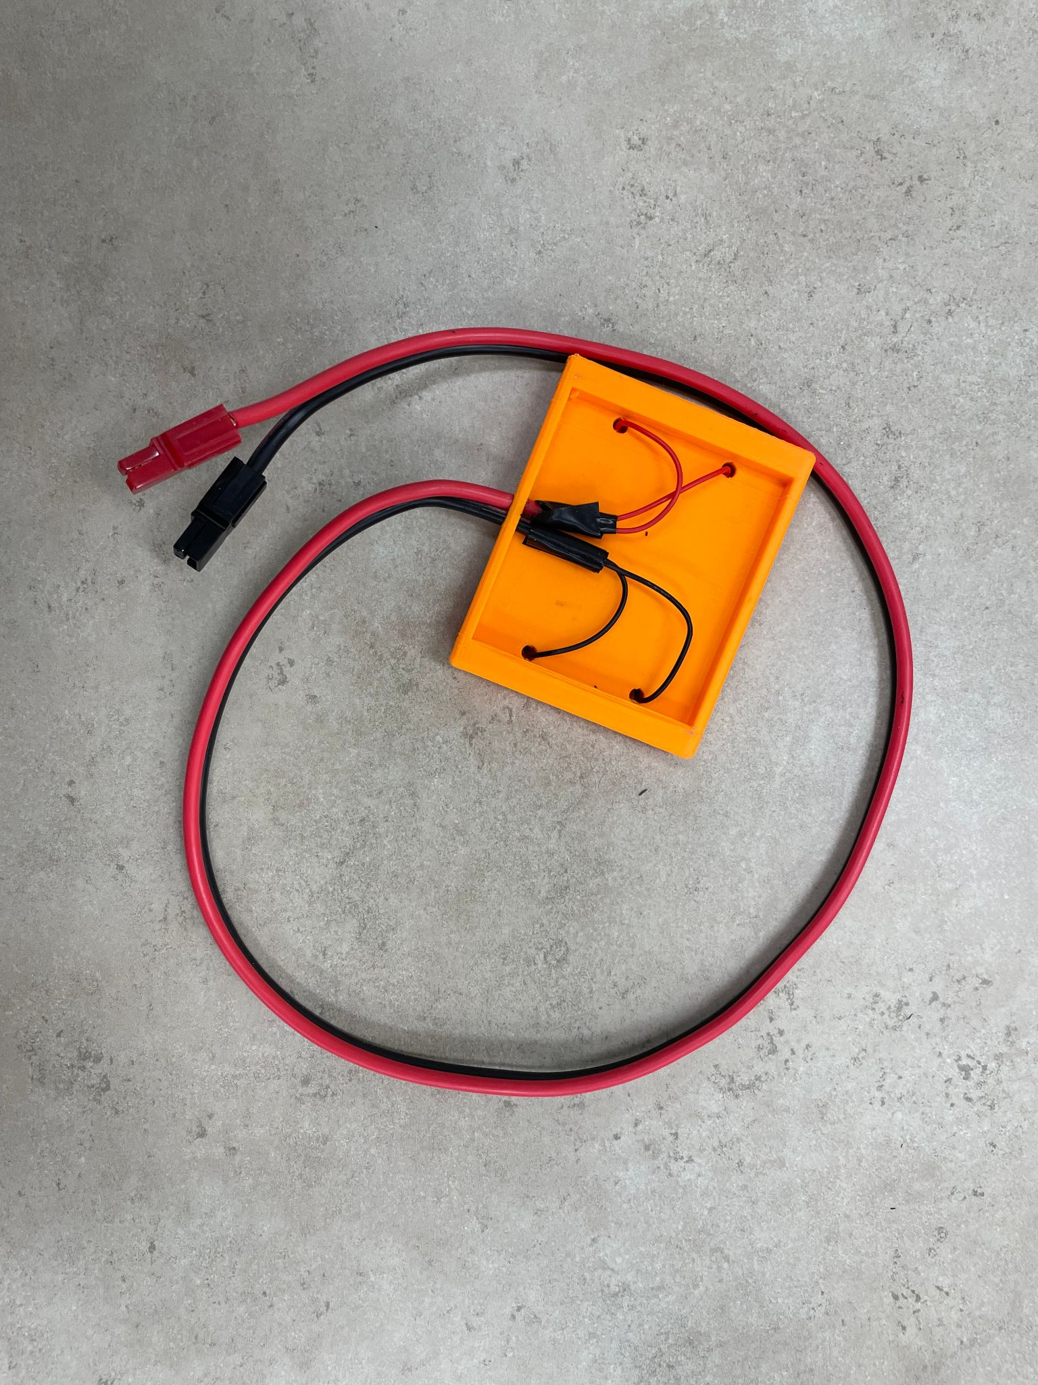
Figure 7. Pyranometer and Solar Panel

Data collection subsystem
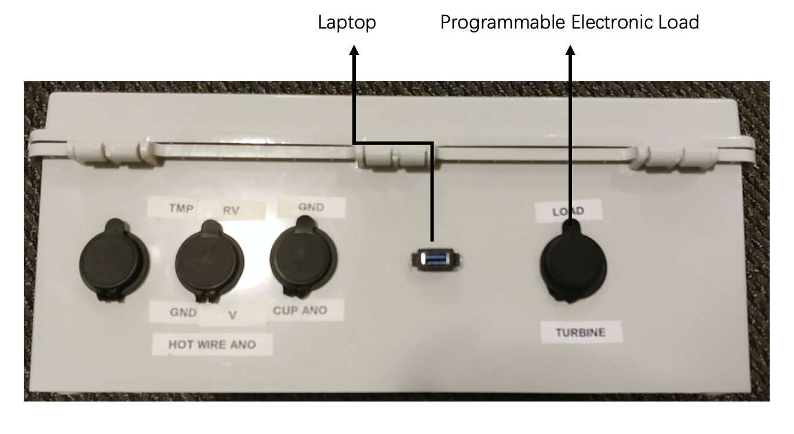
Figure 8. Interface of Data Collection Subsystem
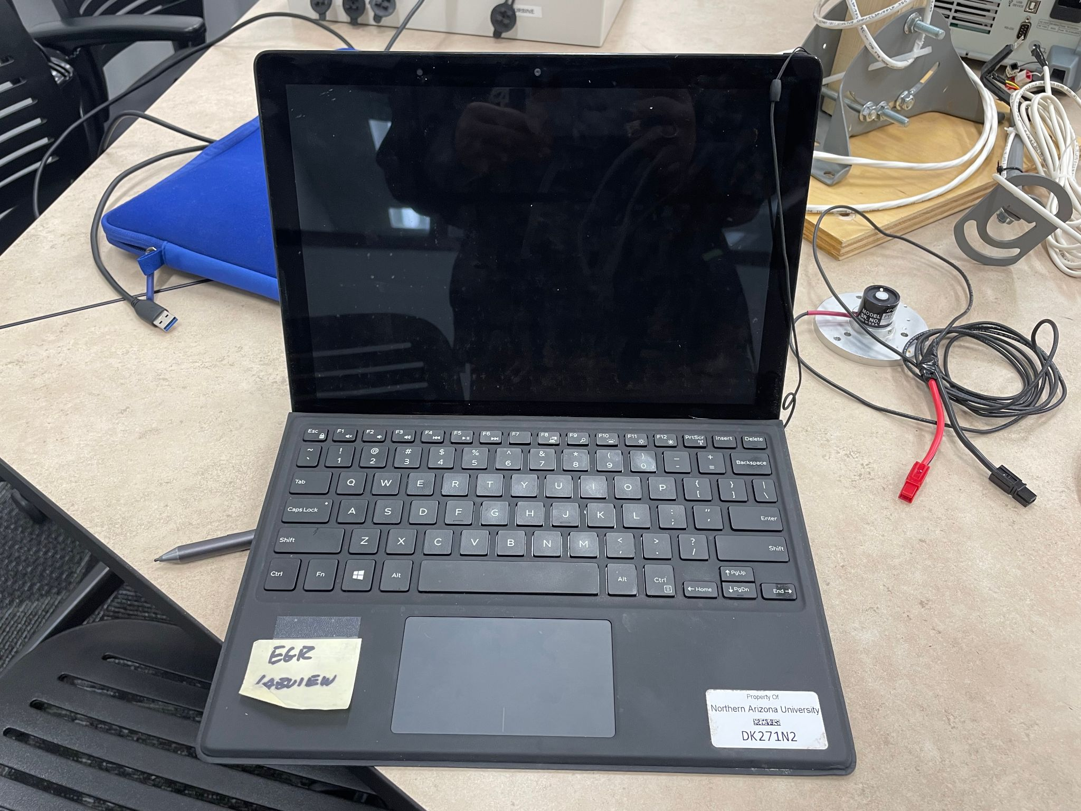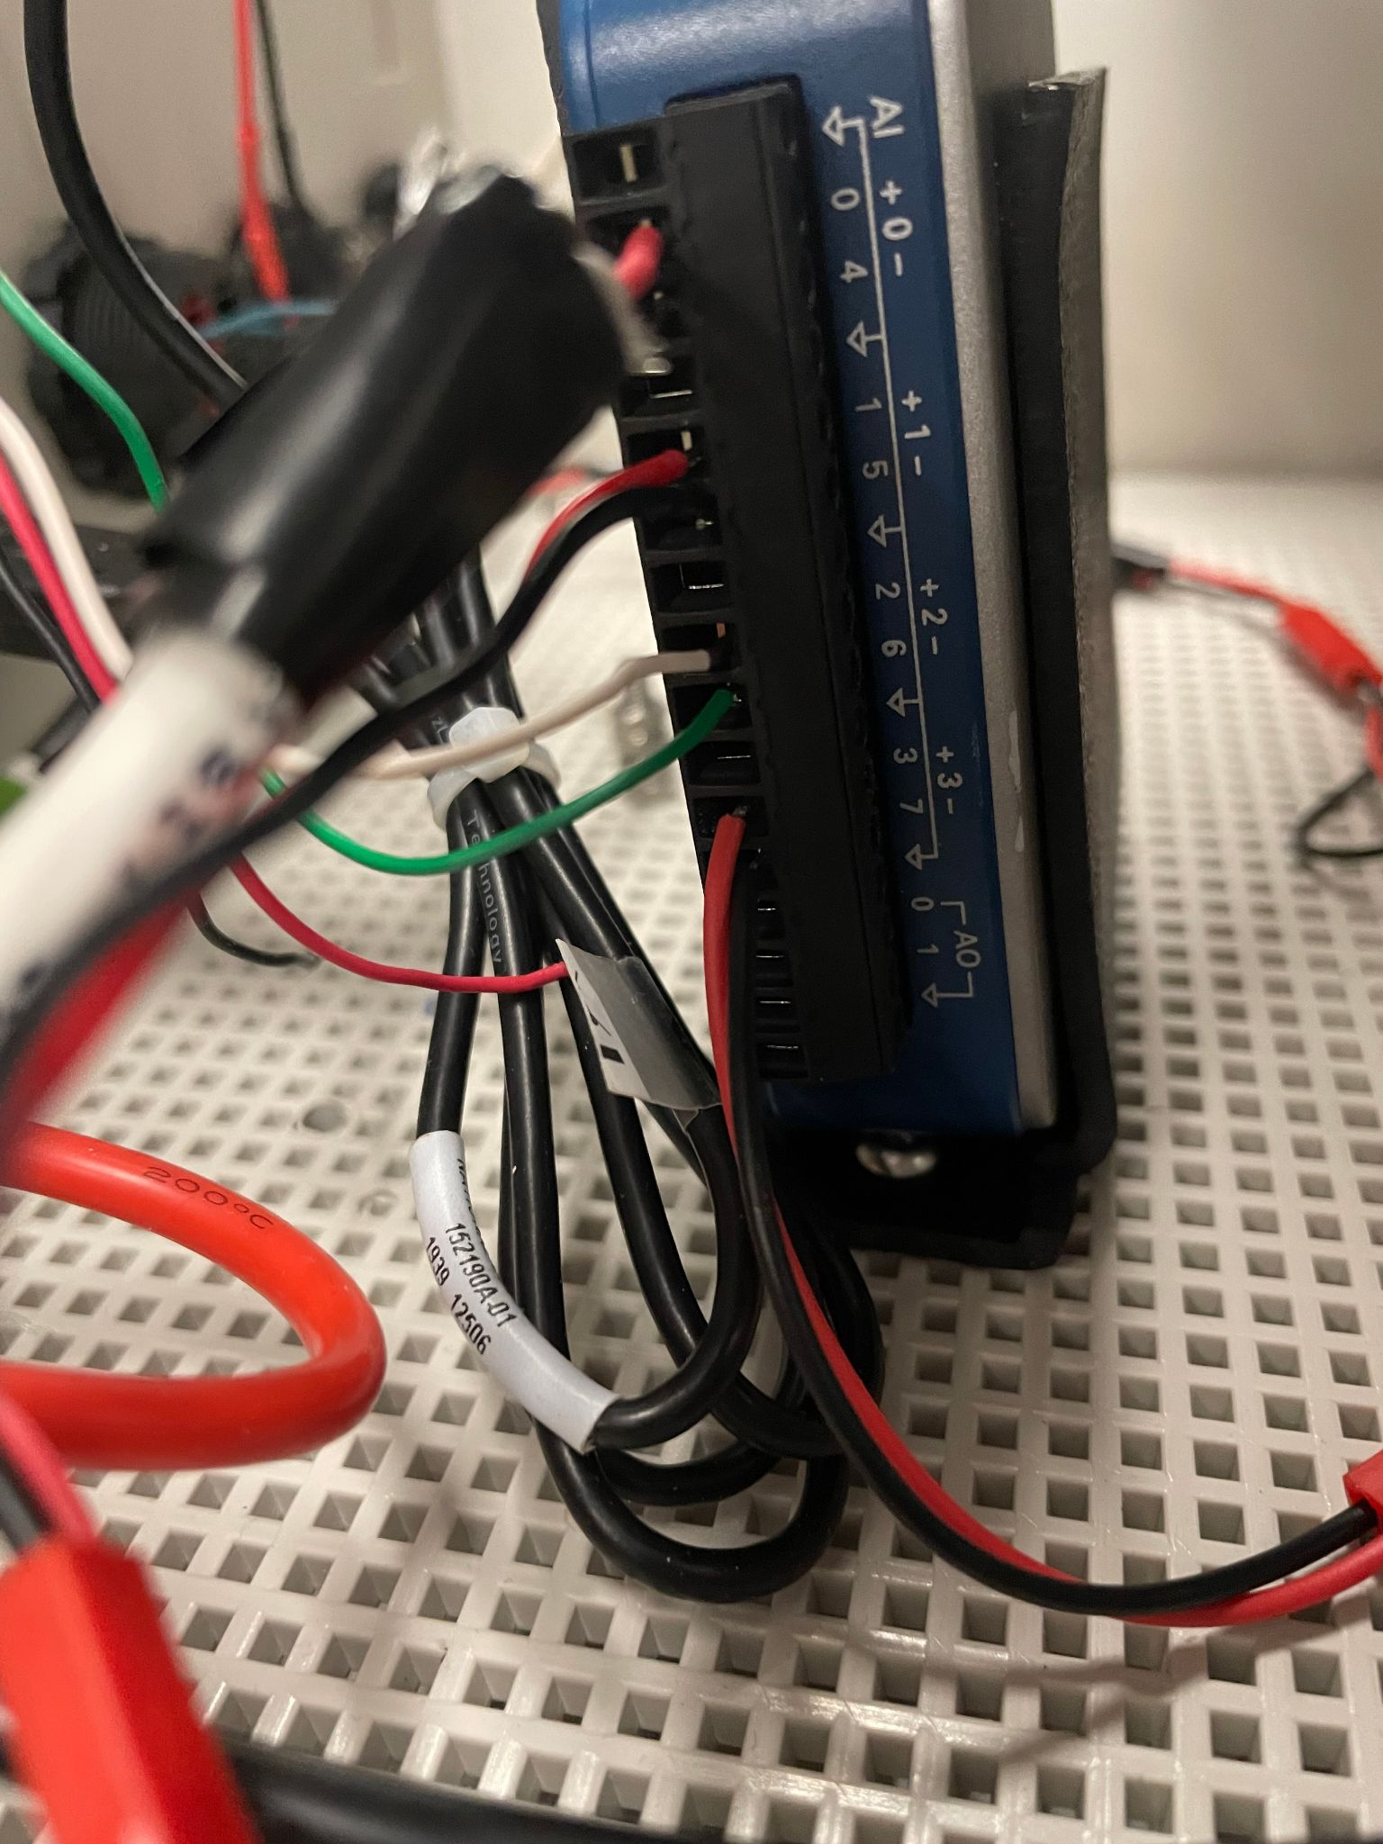
Figure 9. Laptop and Labview Vi
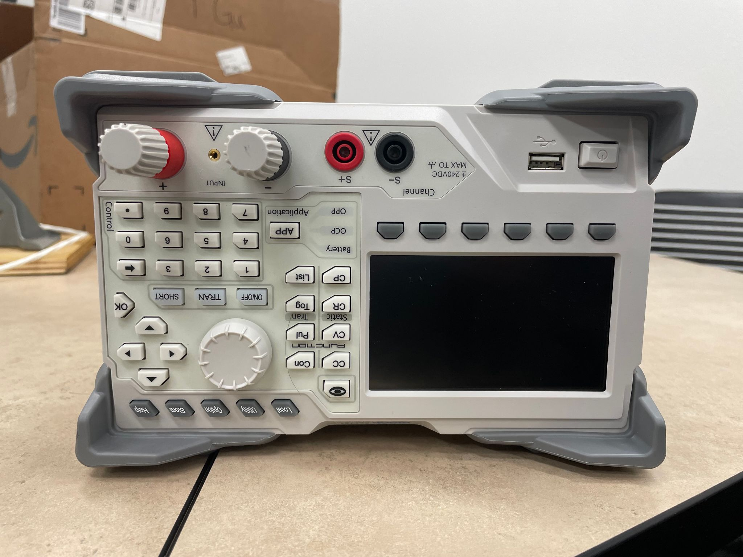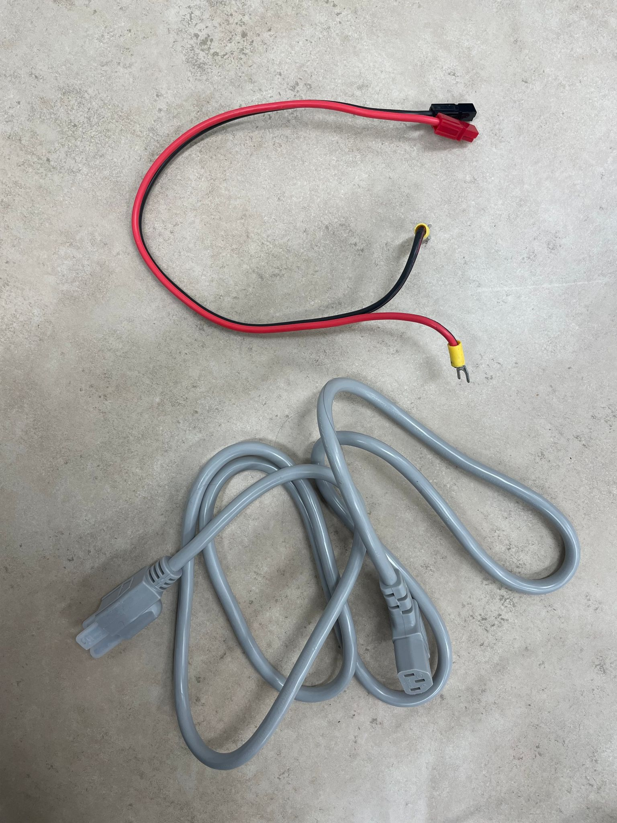
Figure 10. Electric Load and Wires

Operation
Steps:
- Open the required VI file according to the file name;
- Click the ‘DAQmx’ icon and confirm that all plugs are connected to the correct interface according to the reference figure；
- Ensure that the equipments are located in a suitable experimental environment;
- Name the output data file and select the save location;
- Click the ‘Run’ icon to start the programme;
- Observe the data image, and click the ‘Stop’ button after confirming that the required data is obtained;
- If multiple experiments are to be performed, repeat Steps 3-6;
- After the experiment, close the VI program. Disconnect all the equipments and make sure they are placed properly.

Maintenance Instructions
1. Among the interfaces, the interface named CUP ANO is broken, which can not be used.
2. Among the interfaces, the interface named TMP is broken, which can not be used.
3. Among the interfaces, the interface named HOT WIRE ANO is broken, which can not be used.
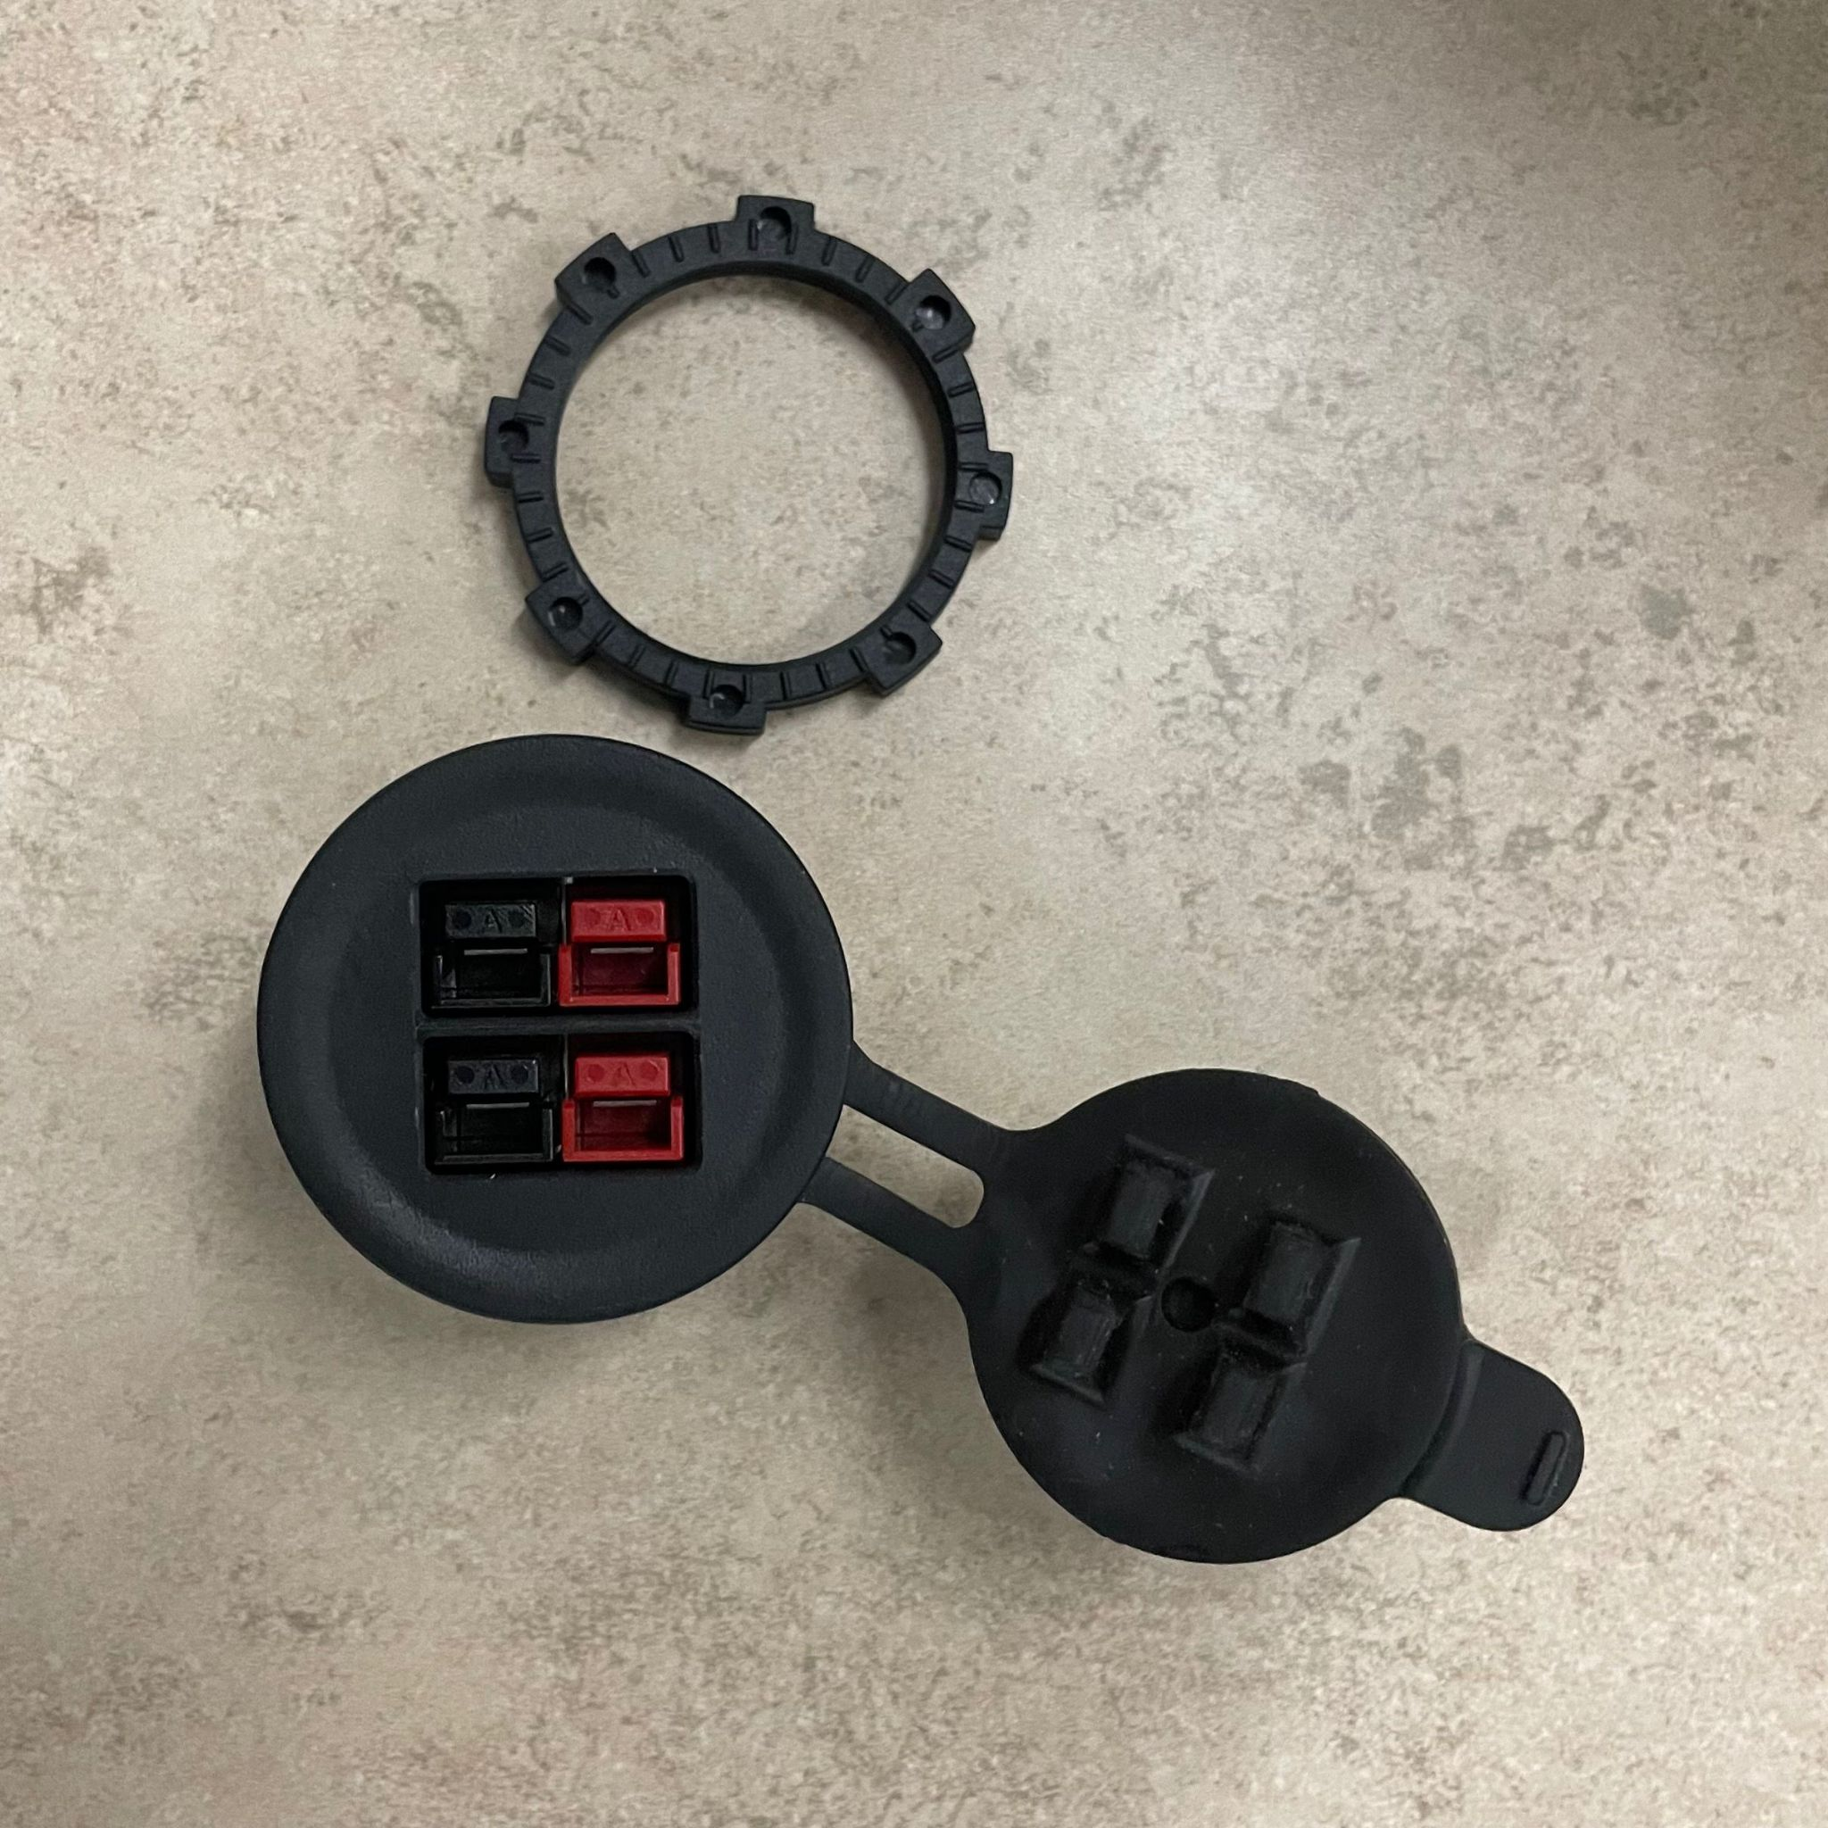

4. If the wires connected to interfaces are broken, the three above are not true or true.
5. If Labview Vi is broken, the four above are not true or some of them are true or all are true.
6. If some of the components are unsoldering, please welding it to normal.
7. If the operation program can not work, believe it, the operation program has no problem.
8. If you lose some components we give you, please rebuy that components.

There are some problems we know currently:
1. The seebeck black wire is unsoldering.
2. The interface we want the sensor to go in are all not available.

